Safeguarding Policy - HAMPSHIRE
Globe Fit acknowledges the duty of care to safeguard and promote the welfare of children and is committed to ensuring safeguarding practice reflects statutory responsibilities, government guidance and complies with best practice. Safeguarding means protecting people’s right to live safely, free from abuse and neglect. It is about people and organisations working together to prevent and stop both the risks and experience of abuse or neglect, while at the same time making sure that child’s wellbeing is promoted including, where appropriate, having regard to their views, wishes, feelings and beliefs in deciding on any action.

Reporting a concern

Globe Fit staff follow the procedures outlined below when they have a Safeguarding concern about a child in their care.
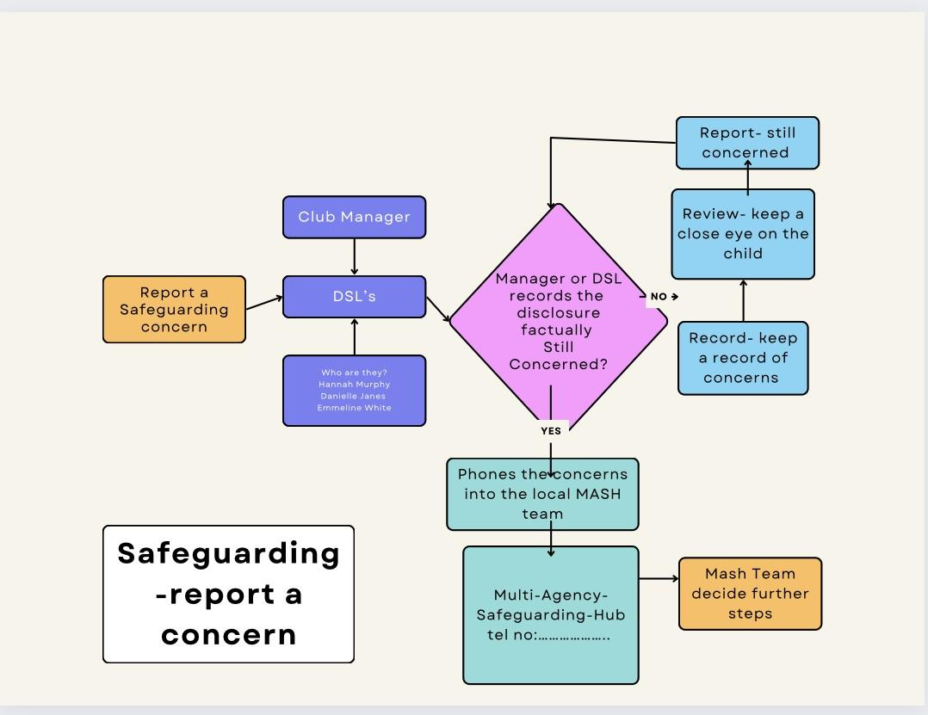

Hampshire MASH team contact details are:
Phone 0300 555 1384
Email childrens.services@hants.gov.uk
Out of hour’s team Phone 0300 555 1373

If the child is in immediate danger call 999

Types of Abuse
- Neglect - A passive form of abuse in which the perpetrator is responsible to provide care, for someone, who is unable to care for oneself, but fails to provide adequate care to meet their needs. Neglect may include failing to provide sufficient supervision, nourishment, medical care or other needs. Neglect is the most common form of abuse for children and is found in about 60% of all referred cases of abuse.
- Physical - Contact intended to cause feelings of intimidation, injury, or other physical suffering or bodily harm. Examples include hitting, slapping, pushing, biting and restraining.
- Emotional - Threats or actions to cause mental or physical harm, humiliation or isolation. Emotional abuse can include threatening a child or trying to coerce them through harassment, verbal abuse or isolation.
- Sexual - The forcing of undesired sexual behaviour by one person upon another. This can be direct abuse of the other person such as rape or sexual touching or by making someone watch images of a sexual nature. Sexual abuse comes about when sexual acts have not been consented to.
- Domestic - The abuse of one partner within an intimate or family relationship using repeated, random and habitual measures to intimidate or control a partner. Children who are witnesses to this behaviour can be significantly affected by what they see and hear. Domestic abuse also involves honour-based violence where children are targeted because they have brought shame to a family or they have violated cultural or religious rules.
- Bullying - Repeated verbal, physical, social or psychological aggressive behaviour by a person or group directed towards a less powerful person or group that is intended to cause harm, distress or fear.
- Modern slavery - This type of abuse encompasses slavery, human trafficking and forced labour. The individuals who perpetrate this form of abuse will use whatever they have at their disposal to coerce, deceive and force individuals into a life they have not agreed to, which is likely to be inhumane and abusive. Slavery and trafficking can apply to children equally as much as adults.
- Munchausen syndrome by proxy (fabricated or induced illness – FII) - This form of abuse is serious but quite rare. It occurs when a parent or carer (most often a child’s biological mother) exaggerates or deliberately causes the symptoms of illness in the child.
- Female genital mutilation (FGM) - FGM is the partial or total removal of female genitalia, through cutting, injuring or changing when there is no medical reason to do so. It is usually carried out on young girls between infancy and the age of 15, most commonly before the onset of puberty. It is illegal in the UK.
- County Lines- Where illegal drugs are transported from one area to another, often across police and local authorities (although not exclusively) usually by children or vulnerable people who are coerced into it by gangs.

Updated August 2023 by Danielle Jenner

